**EVENT LIST**

**Visitor:**

The Visitor can perform the following tasks:

1. Visitor browses Home Page/Menu/Events/Contact Us /About Us.
2. Visitor wants to register.

**Customer:**

The Customer can perform the following tasks:

1. Customer browses Home Page/Menu/Events/Contact Us /About Us.
2. Customer Logs in.
3. Customer wants to book for event.
4. Customer places new order.
5. Customer requests for cancel/modify the order.
6. Customer wants to send query.
7. Customer tracks booking details.
8. Customer tracks the order details.
9. Customer wants to modify his/her details.

**Admin:**

The Admin can perform the following tasks:

1. Admin browses Home Page/Menu/Events/Contact Us /About Us.
2. Admin provide new menu item details.
3. Admin provide new event details.
4. Admin can modify bill.
5. Admin wants to view bill.
6. Admin wants to view the customer details.
7. Admin wants to view the menu details.
8. Admin wants to view the order details.
9. Admin wants to view the order summary.
10. Admin wants to view the enquiry summary.
11. Admin wants to view the cancel summary.
12. Admin wants to view the payment summary.
13. Admin responds to the query.

**EVENT TABLE**

|  |  |  |  |  |  |
| --- | --- | --- | --- | --- | --- |
| **Event** | **Trigger** | **Source** | **Activity/Use case** | **Response** | **Destination** |
| Visitor browses Home Page/Menu/Events/Contact Us /About Us | Click on the Home Page/Menu/Events/Contact Us /About Us | Visitor | Load Home Page Home Page/Menu/Events/Contact Us /About Us | Displays Home Page /Products/Feedback/Contact Us/About Us. | Visitor |
| Visitor wants to register. | New registration | Visitor | Create new registration | Registration confirmation  Registration details | Visitor  Admin |
|  |  |  |  |  |  |
| Customer browses Home Page/Menu/Events/Contact Us /About Us. | Click on the Home Page/Menu/Events/Contact Us /About Us. | Customer | Load Home Page/Menu/Events/Contact Us /About Us. | Displays Home Page/Menu/Events/Contact Us /About Us. | Customer |
| Customer Logs in. | Fill Login credentials | Customer | Record and verify Login details | Login successful | Customer |
| Customer wants to book for event. | New Booking | Customer | Create new booking | Booking confirmation  Booking details | Customer  Admin |
| Customer places new order. | New order. | Customer | Create new order. | Order Confirmation.  Order Details, | Customer  Admin |
| Customer requests for cancel/modify the order. | Request order cancellation/ modification | Customer | Update order | Updated order confirmation | Customer |
| Customer post query. | New query | Customer | Record Query Details. | Query details | Admin |
| Customer tracks booking details. | Booking status enquiry | Customer | Load Booking Status details. | Booking status details | Customer |
| Customer tracks the order details. | Order status enquiry | Customer | Load Order details | Order details | Customer |
| Customer wants to modify his/her details | Requests modification. | Customer | Update Details. | Updated customer details. | Customer |
|  |  |  |  |  |  |
| Admin browses Home Page/Products/Reviews/Feedback/Contact Us/About Us | Click on the Home Page/ Products /Reviews/ Feedback/ Contact Us/ About Us. | Admin | Load Home Page/Products/Reviews/Feedback/Contact Us/About Us | Displays Home Page/Products/Reviews/Feedback/Contact Us/About Us | Admin |
| Admin provide new menu item details. | New menu item. | Admin | Create new menu item. | Menu Item details. | Admin |
| Admin provide new event details. | New event. | Admin | Create new event. | Event details | Admin |
| Admin can modify bill. | Select bill details. | Admin | Update bill. | Updated bill details. | Admin |
| Admin wants to view bill. | Select on bill details. | Admin | Load bill details. | Display bill details | Admin |
| Admin wants to view the customer details. | Select on customer details. | Admin | Load customer details. | Display customer details. | Admin |
| Admin wants to view the menu details. | Select on menu details | Admin | Load menu details | Display menu details | Admin |
| Admin wants to view the order details | Select on order details | Admin | Load order details | Display order details | Admin |
| Admin responds to the query. | Fill response details. | Admin | Record response details | Response details. | Customer |
| Admin wants to view the order summary. | Select on order summary. | Admin | Load order summary. | Display order summary. | Admin |
| Admin wants to view the cancel summary. | Select on cancel summary. | Admin | Load cancel summary. | Display cancel summary. | Admin |
| Admin wants to view the payment summary. | Select on payment summary. | Admin | Load payment summary. | Display payment summary. | Admin |
|  |  |  |  |  |  |

**CLASS DIAGRAM**

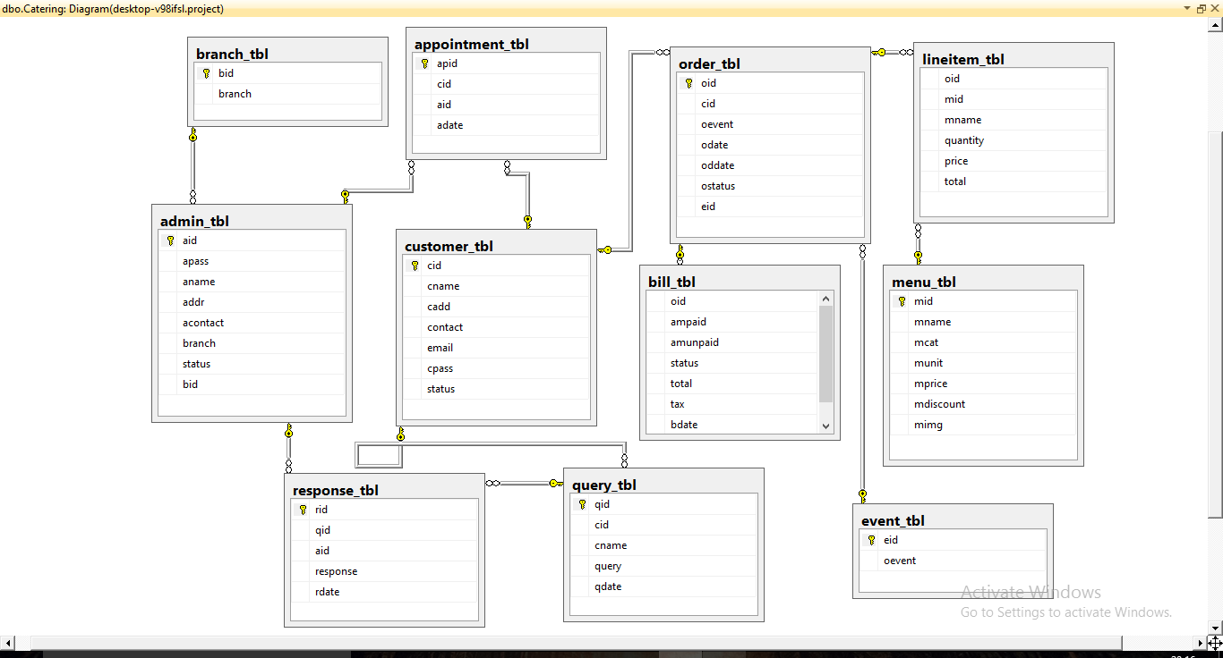

**USE CASE DIAGRAM**

**VISITOR:**

**CUSTOMER:**

**ADMIN:**

**SEQUENCE DIAGRAM**

**VISITOR:**

**CUSTOMER:**

**ADMIN:**